Teacher dashboard

**Home video lectures study material Take Test My Sessions My students Schedule Sesssion** **My profile/ logout**

**My students**

**(Recent students)**

**Student profile**

**Message Schedule Class**

Subject Grade

Topic

Date and time

**Schedule the class**

**Email/message to student for class…date time**

On teacher home page

Teacher dashboard

**Home video lectures study material Take Test My Sessions My students** **My profile/ logout**

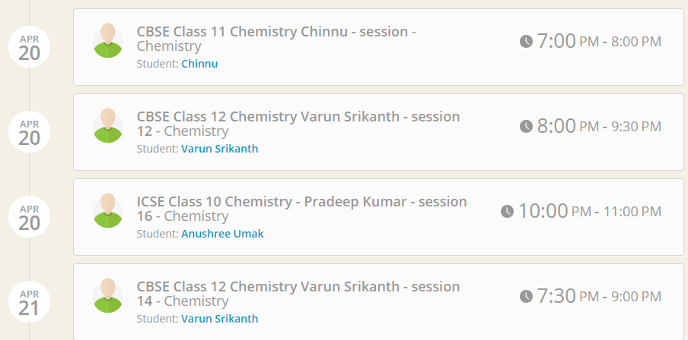Teacher home page will be having MY SESSIONS like this example with date and time

At right time the JOIN session should get activated like this

